**Lab 4 - [Network commands]**

# Objective

● To study about and use the following network commands

1. ping
2. netstat
3. ipconfig
4. hostname

# Theory

* **hostname command**: This command is used in networking to find out about the host of the network, in our cases the computer/laptop we are using.
* **netstat command**: This command is used in networking to find out every active TCP connection made by the host (our computer).

○ It consists of different options:

■ -a: Displays all connections and listening ports.

■ -e: Displays Ethernet statistics.

■ -i: Displays the time spent by a TCP connection in its current state.

■ -s: Displays per-protocol statistics. By default, statistics are shown for IP, IPv6, ICMP, ICMPv6, TCP, TCPv6, UDP, and UDPv6;

* **ipconfig command**: This command is used in networking to find out about the IP address, Gateway address, subnet mask, etc about our computer in the current network
* **ping command**: This is the primary TCP/IP command used to troubleshoot connectivity, reachability, and name resolution.

# Output

* hostname and ipconfig command

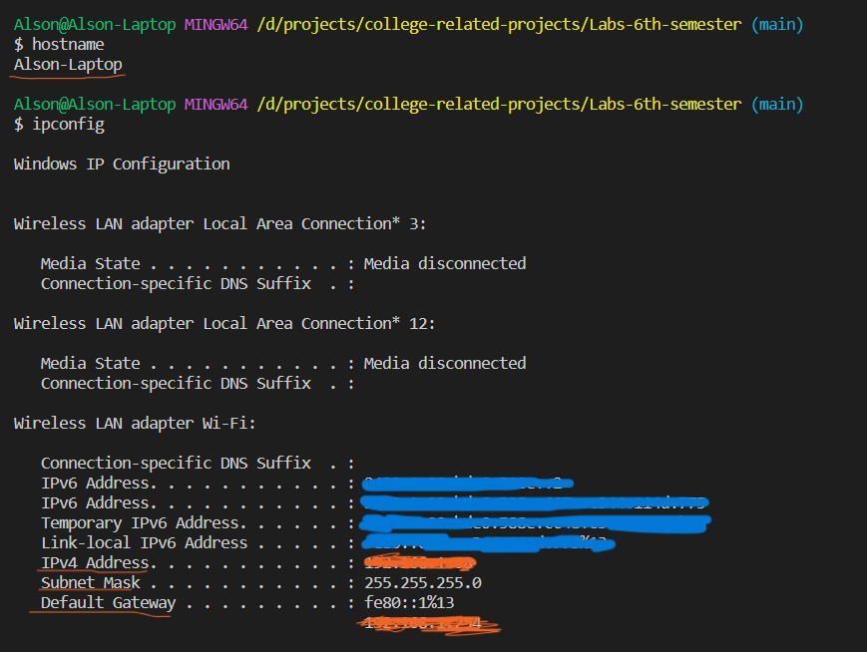

* netstat and ping command

